**Classroom Automation**

**S. R. S. Report – I**

**Group No. 12**



**Members:**

Ayush Khattri

(161500159)

Apoorv Gaur

(161500114)

Archit Gupta

(161500120)

Arnav Gupta

(161500121)

**Supervisor:**

Mr. Ambrish Gangal

Assistant Professor

Department of Computer Engineering & Applications

**Table of Contents**

Revision History ii

Document Approval ii

1. Introduction 1

1.1 Purpose 1

1.2 Scope 1

1.3 Definitions, Acronyms, and Abbreviations 1

1.4 References 1

1.5 Overview 1

2. General Description 2

2.1 Product Perspective 2

2.2 Product Functions 2

2.3 User Characteristics 2

2.4 General Constraints 2

2.5 Assumptions and Dependencies 2

3. Specific Requirements 2

3.1 External Interface Requirements 3

3.1.1 User Interfaces 3

3.1.2 Hardware Interfaces 3

3.1.3 Software Interfaces 3

3.1.4 Communications Interfaces 3

3.2 Functional Requirements 3

3.2.1 <Functional Requirement or Feature #1> 3

3.2.2 <Functional Requirement or Feature #2> 3

3.3 Use Cases 3

3.3.1 Use Case #1 3

3.3.2 Use Case #2 3

3.4 Classes / Objects 3

3.4.1 <Class / Object #1> 3

3.4.2 <Class / Object #2> 3

3.5 Non-Functional Requirements 4

3.5.1 Performance 4

3.5.2 Reliability 4

3.5.3 Availability 4

3.5.4 Security 4

3.5.5 Maintainability 4

3.5.6 Portability 4

3.6 Inverse Requirements 4

3.7 Design Constraints 4

3.8 Logical Database Requirements 4

3.9 Other Requirements 4

4. Analysis Models 4

4.1 Data Flow Diagrams (DFD) 5

4.2 ENTITY RELATIONSHIP DIAGRAM 5

# 1. Introduction

The Automation is a very common topic around the world. Lots of real life project and research is currently developing based on IOT. Automation is more popular and quickly makes a better position in market and gives a greater field to work and research for the engineers.

Here we design project using the Relay Switch to control electronics appliances and devices. The Relay is connected to the mobile device or PC with internet connection. An automatic fan and light is the part of this project, which is automatically switched On and Off according to the time table.

## 1.1 Purpose

Classroom automation basically focuses on the automation of lights and fans according to time table. The electricity loss will be reduced to a much larger extent by implementing this project.

**1.2 Scope**

The product will be called Class Room Automation. This product is great ingenuity. The product will take the level of ordinary classrooms beyond imaginations. Imagine a class with fully automatic geared appliances where no students or the teacher has to bother about anything else except studying. This product will automatically switch on or off the different appliances in the classroom on its own based on scheduled timetables. For this, we will have to manage a database. This will not only help us in managing the product easily but also will update in timetable can be handled directly through the database without disturbing the functionality of the product and without changing the actual code. The database can be saved on the main server, this will help in running the whole system all the time. For managing the database, we will assign an Admin who will have the authority of managing the data in the database.

Also, the product will be added with some more functionalities like:

1) Manual control: This depends on the user whether he needs the service or not. For e.g. if the teacher is willing to extend the session, he can control the appliances through this

module.

2) The product will be capable of judging the presence of the crowd in the room (future aspect). In case, at the scheduled time if the class is not being conducted then, the PIR sensors will sense if the crowd is in the room or not and will turn the system to sleep mode automatically.

For controlling the appliances, we will use the USB Relay switch, for creating back end and

other functionalities and control we will use technology-PYTHON and Windows Powershell

to control relays.

## 1.3 Definitions, Acronyms, and Abbreviations

1) The Admin: Admin will be the person who will make the changes in the database as per the requirement.

2) Appliances: Fans, AC, LEDs.

3) USB Relays: Relays are switches that open and close circuits electromechanically or electronically. Relays control one electrical circuit by opening and closing contacts in another circuit. As relay diagrams show, when a relay contact is normally open (NO), there is an open contact when the relay is not energized. The USB relay board has two relays that can easily be controlled from a computer.

4) Python: Python is an interpreted high-level programming language for general-purpose programming. Created by Guido van Rossum and first released in 1991, Python has a design philosophy that emphasizes code readability, notably using significant whitespace.

5) Java: Java is a general-purpose computer-programming language that is concurrent, class-based, object-oriented, and specifically designed to have as few implementation dependencies as possible.

6) Windows PowerShell: PowerShell is the shell framework developed by Microsoft for administration tasks such as configuration management and automation of repetitive jobs. The term 'PowerShell' refers to both – the shell used to execute commands and the scripting language that goes along with the framework**.**

## 1.4 References

(a)YouTube

(b)Codeacademy – “Learn SQL”: https://www.codecademy.com/learn/learn-sql

(c) IEEE Recommended Practice for Software Requirements Specifications – IEEE Std 830-1998.

(d) IEEE Standard for Software Test Documentation – IEEE Std. 829-1998.

(e)https://www.google.co.in /amp/s/myhydropi.com/relay-timer-using-database/amp

(f) https://stackoverflow.com

## 1.5 Overview

# The remaining sections of this document provide a general description, including characteristics of the users of this project, the product, hardware, and the functional and data requirements of the product.  General description of the project is discussed in section 2 of this document.  Section 3 gives the requirements like functional requirement, non-functional requirements, data requirements and constraints and assumptions made while designing the product.  It also gives the user viewpoint of product.  Section 3 also gives the specific requirements of the product.  Section 3 also discusses the interfaces requirements and gives detailed description of functional requirements. Section 4 is for supporting information.

# 2. General Description

The Classroom Automation is an IOT based project. The product provides the following functionality (using Time Table):-

(a) Automatic lights and fans.

(b)Manual control.

Future goals-

(a) Automated Air conditioners.

(b) Automatic Attendance Management System through face recognition.

(c) Capability of sensing the presence of students entering in the class.

The product is an integrated product of different subparts. These are as follows-

(a) A database consisting timetables.

(b) A dedicated main server.

(c) USB Relay Switch.

(d) A dedicated Network.

(e) PIR sensors for more functionalities.

(f) A user interface.

## 2.1 Product Perspective

Our Project will add a bit more the simple automation. It should control lights and fans according to the time table.

## 2.2 Product Functions

The Product is able to control all the appliances within the class room. Product will run automatically as soon as the system gets connected to the Time-Table database managed by Admin. For more functionality the product has the feature to provide control to the User to control the appliances using an interface. The product is also capable of sensing the presence if crowd in the classroom (future goals) so that system could be shut down on its own when the scheduled class is cancelled for any reason. This could be also managed manually.

The system can control-

1) Lights

2) Fans

## 2.3 User Characteristics

The characteristics of the project will be effected by the absence of electricity. Presence of electricity is mandatory for our project.

## 2.4 General Constraints

The system it is connected to should remain active as to provide clock pulse.

## 2.5 Assumptions and Dependencies

If the project needs to be working even when the system is off, we will need an arduino and an Ethernet shield to connect it to the LAN for all time connectivity.

# 3. Specific Requirements

Each requirement in this section should be:

* IDE
* WAMP Server
* USB Relays
* PIR Sensors
* Arduino

## 3.1 External Interface Requirements

### 3.1.1 User Interfaces

### This module will be developed with Python Tkinter or PyQt.

### 3.1.2 Communication Interfaces

### Communication between database and control system will be through LAN or wifi.

## 3.2 Functional Requirements

**3.2.1 Introduction:**

Functional requirements denote the functions that a developer must built into the software to achieve use cases. The functional requirements for classroom automation are the according to the use cases:

The functions will be implemented in such a way that it takes data from the time table and switches the electric appliances on and if the class is free, it will be automatically switched off.

The functionality of the classroom automation interface shall be implemented in such a way such that it is homogenous , based on standards and convenient to use according to the requirements.

**3.2.1.2 Inputs:** Data from database.

**3.2.1.3 Processing :**

Firstly data will be read by the component and if the classroom has any lecture , then the appliances will be turned on 5 minutes before the lecture starts(if the classroom has its first lecture of the day).The appliances will keep on running continuously unless it finds any library or any free lecture . Moreover , the appliances will be switched off as soon as the lecture gets over , but if a teacher has to extend its class , he or she has to send an information to the server/ arduino beforehand to continue running the appliances and soon as the extended class gets over either he/she has to again send information or by judging the motion it will automatically turned things off.

**3.2.1.4 Outputs:**

Electricity Saving to a much higher extent.

## 3.3 Use Cases

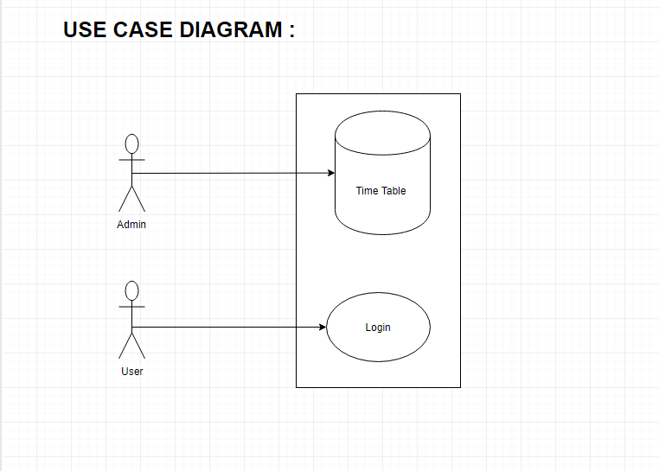

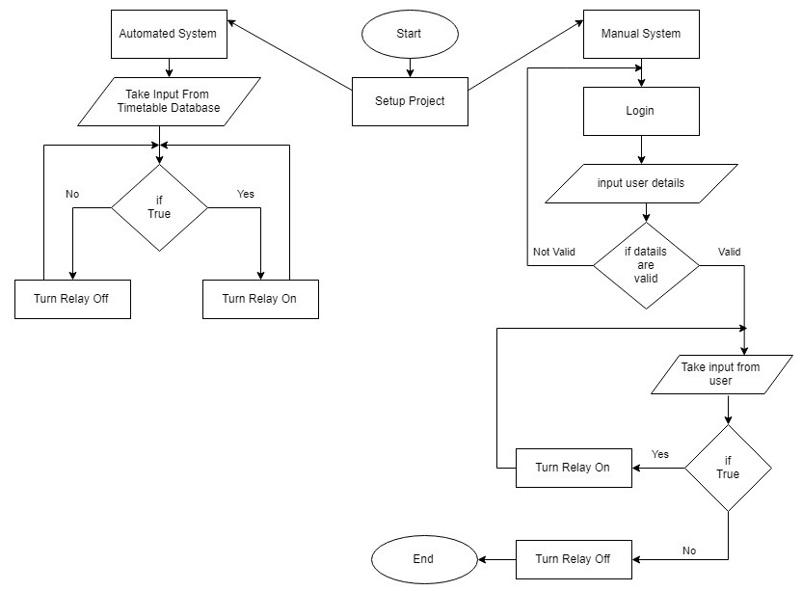

## 

## 3.5 Non-Functional Requirements

Every time that we plan around a software project, we tend to only think about main functionalities and final goals, minimizing the perspective of what it really takes to be accomplish; Although it is totally fine and natural , especially if you are planning to go for a LEAN software development approach. In many cases, what is not good about it, is that the final product is only measured in terms of our primary needs and goals, but those needs and awesome functionalities imply a lot of non-functional requirements that are not usually contemplated.

Non-functional requirement specifies how the system behaves in terms of constraints or prerequisites. We can list them with expressions like: it should be fast, should be secure, should be multi-platform, should be portable, should be scalable, etc.

We, as professionals, need to keep all these non-functional requirements always into account, especially during the estimation/cost phase. It is part of our job to guide team members that are new to the estimation and planning process. No matter what is the hurry, because even we can defer some of them, we should never forget them as they also take time and money to be fulfilled. So we do not want surprises when we think we are about to be done with our project. I have seen many projects fail because a neglected budget estimation due to non-functional requirements.

### 3.5.1 Performance:

Performance becomes better as it is totally dependent on time and in terms of electricity consumption it plays a vital role.

### 3.5.2 Reliability:

Only reliable on data and the people who are engaged in accessing the control if it.

### 3.5.3 Security:

Guarantees security as it will only be accessed by the main stakeholders.

### 3.5.4 Maintainability:

Easy maintenance as it is not accomplished with complex connections , and for data manipulations admin just has to change the data for particular slot only.

## 4.1 Data Flow Diagrams (DFD)

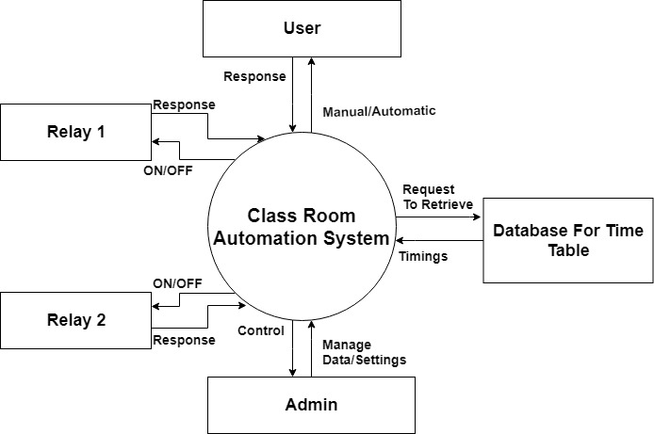

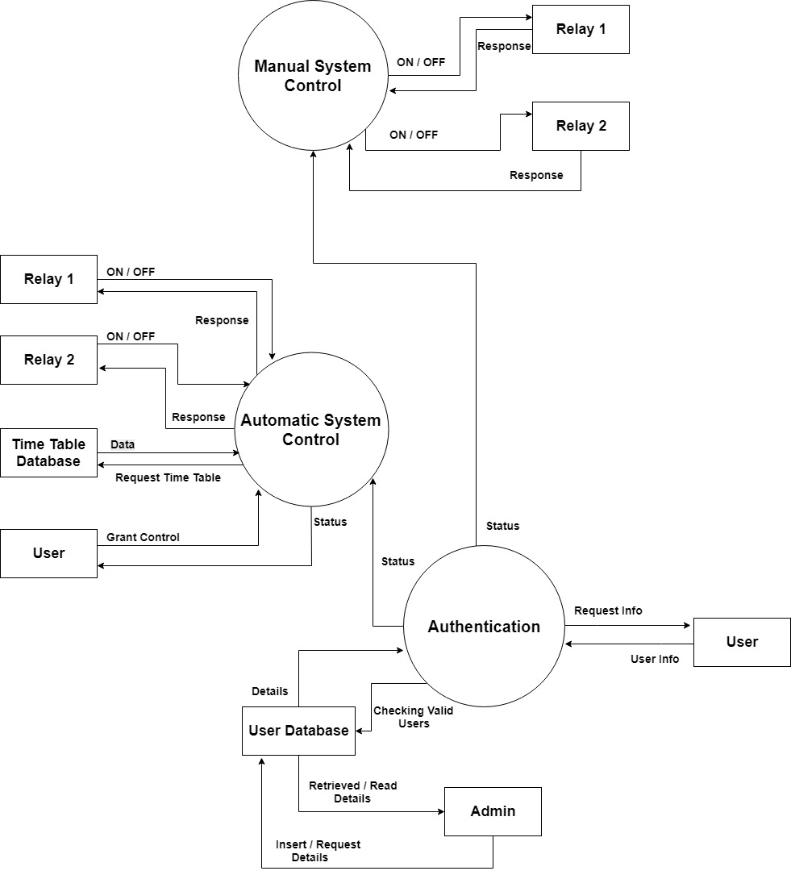

## 4.2 Entity Relationship Diagrams (ERD)



